CREATING SPRITE USING KRITA

* Open Krita and create a new document by going to File > New.
* Choose the canvas size for your sprite. Sprites are typically small, so you might want to use something like 32x32 or 64x64 pixels, depending on the size of your game objects.
* Set the resolution to 72 DPI (dots per inch), which is common for digital art and games.
* Make sure to draw your sprite on a transparent background. If the default background is white, you can remove it by hiding or deleting the background layer, or selecting the white area and deleting it
* Ensure that your sprite maintains transparency by checking that the alpha channel (transparency) is enabled.

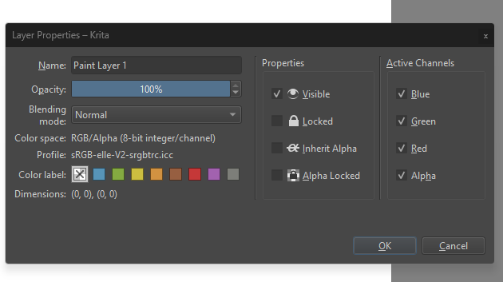

* Use the brush tool to draw your sprite. For pixel art sprites, you can use a simple hard round brush with a 1-pixel brush size to ensure crisp, clean edges.
* Krita has a pixel art mode you can activate by selecting the pixel brush and enabling the grid (View > Show Grid) for easier placement of pixels.

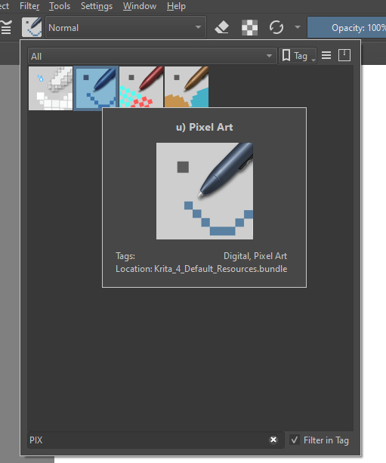

* Choose a limited color palette to make your sprite look more consistent and game-ready.
* In Krita, you can export a spritesheet using the Animation Timeline feature, which allows you to create frame-by-frame animations and then export them as a spritesheet
* Make sure you enable animation settings by going to Settings > Dockers > Timeline to open the animation timeline at the bottom of the workspace.

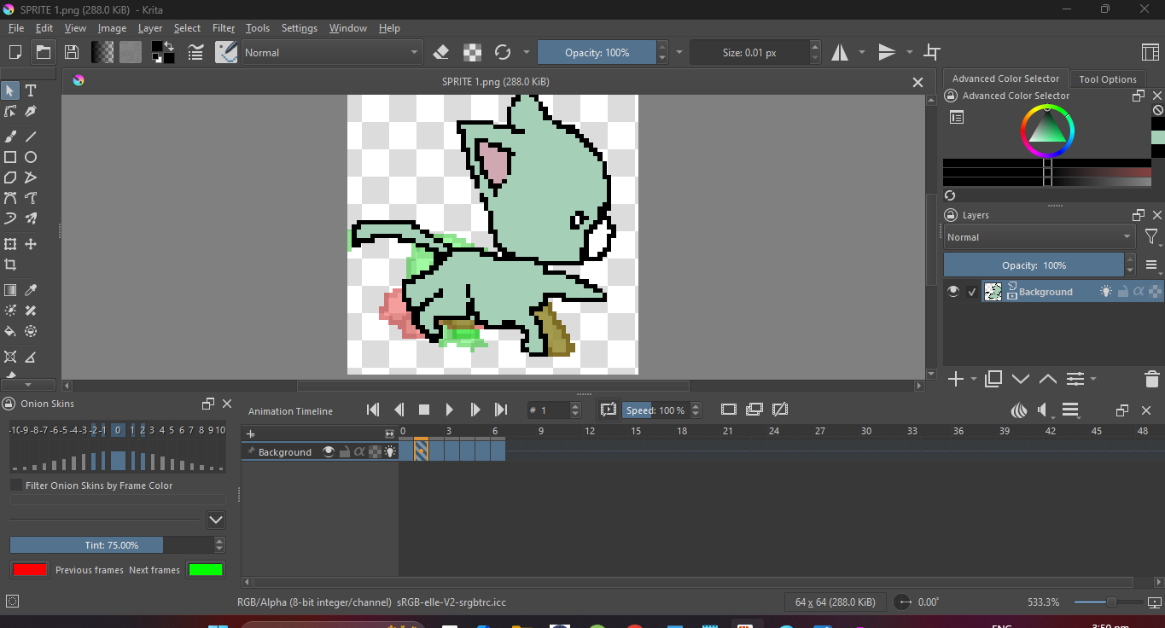

* Use the Play button in the timeline to preview your sprite animation. Make sure all the frames look correct and the animation flows smoothly.
* Once your frames are ready, go to File > Render Animation. In the Render Animation window, set the following options:
* Export: Select Image sequence (because you need the individual frames for a spritesheet).
* File format: Choose PNG (for transparency support)

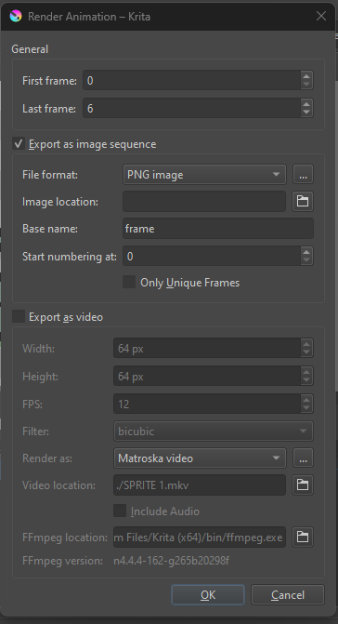

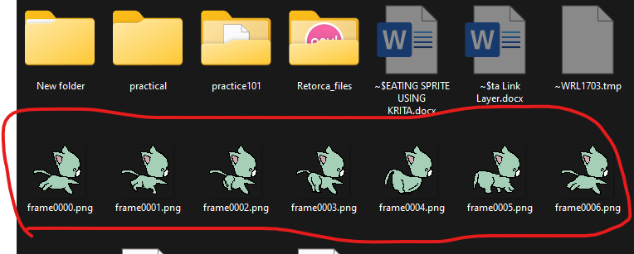

* Use external generator : <https://www.codeandweb.com/free-sprite-sheet-packer>

to combine all the frames into 1 file png

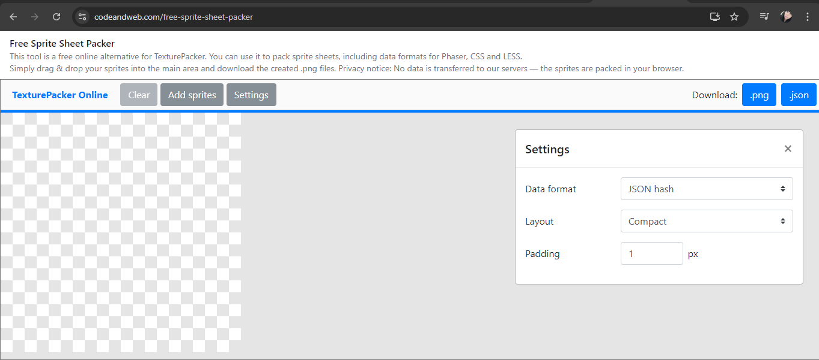

* 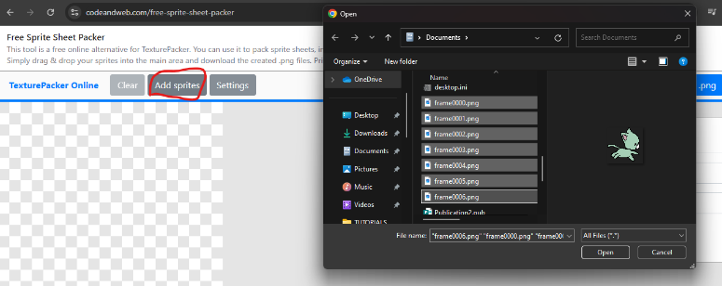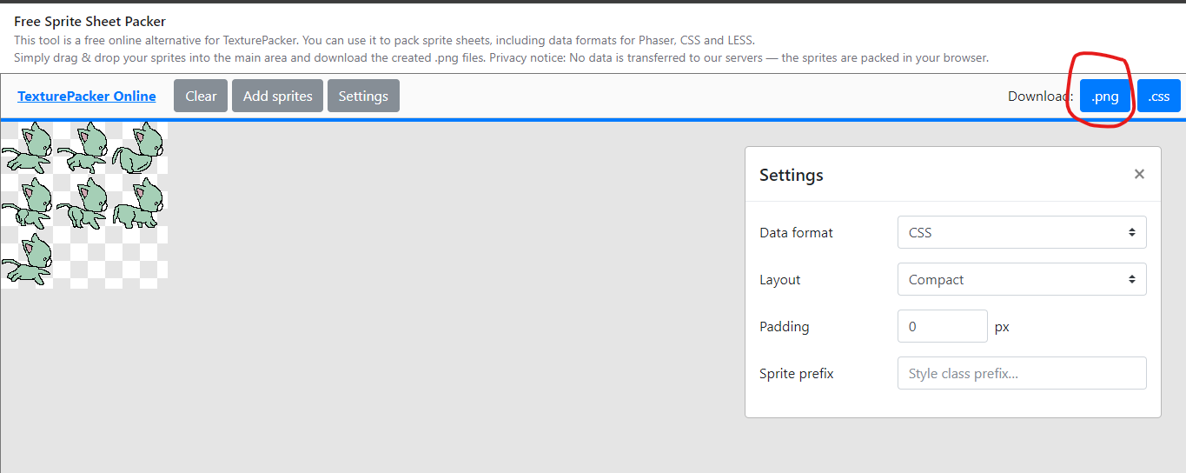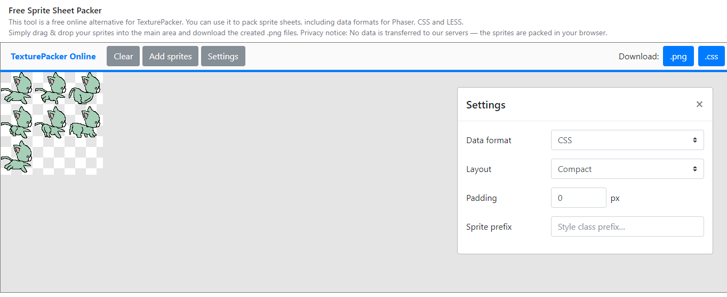Click add sprite and upload all the frames.
* Set your file to image below
* Final output

